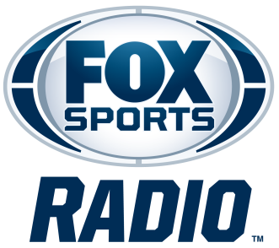

COVINO & RICH
BIOGRAPHY
Covino & Rich joined FOX Sports Radio’s weekday lineup in September 2022. Broadcasting Monday through Friday from 5 to 7 p.m. ET/2 to 4 p.m. PT, this sports-focused program from veteran radio and podcast personalities Steve Covino and Rich Davis features their unique take on the hot sports topics of the day, injected with their brand of humor, fun and relatability. The program can be heard on more than 340 stations nationwide, in addition to FOX Sports Radio’s channel on iHeartRadio, which is available via iHeartRadio.com and the iHeartRadio app. The program is also available as a podcast directly following each show.
After joining FOX Sports Radio's weekend football lineup in 2021, Covino & Rich quickly became a fixture on the network and moved to weekdays the following year. Their partnership, however, stretches back much further. The longtime Covino & Rich podcast debuted in 2004 on Sirius' Maxim Radio and aired on SiriusXM for 16 years before transitioning to a subscription-based Patreon format in 2021. Covering sports, entertainment, lifestyle, relationships, comedy, and music, the show has built a loyal audience over two decades. Covino & Rich also previously aired on ESPN and SNY, the NBC sports affiliate in New York City
In 2023, Covino and Rich launched Overpromised with Covino & Rich, a weekly podcast that explores the headlines, trends, and debates that don't always make it into their daily radio show. Fueled by their signature chemistry and quick wit, the podcast offers an entertaining mix of sports, pop culture, and everyday life.
A defender of New Jersey and a proud Yankees fan, Covino has a passion for rock music, bringing that to life every night as the host of SiriusXM Turbo 41. He also hosts weekend mornings on Ozzy’s Boneyard - SiriusXM channel 38. Covino previously worked at K-ROCK/WXRK-FM in New York. A loyal Mets fan and softball enthusiast, Rich is one of the lead voices in pop music for SiriusXM, with hosting duties on their Pop2K channel, Hits 1 and The Pulse. His resume includes stints at iHeartMedia’s Z100/WHTZ in New York, Q102/WIOQ in Philadelphia and HOT 107.9/WWHT in Syracuse.
For more information, please visit https://covinoandrich.com/.
# # #

